AI ASSISTED CODING
LAB 18 – API INTEGRATION: CONNECTING TO EXTERNAL SERVICES WITH ERROR HANDLING

Name: N.rahul
Roll Number: 2503a52403
Batch: 14

Task 1 – Weather API Integration
1. Question: Connect to a Weather API and fetch the current temperature, humidity and weather description for a city entered by the user. Handle invalid city names, API errors and network failures.
2. AI Prompt: Write Python code using requests and a free weather API to display a city’s current temperature, humidity and condition. Include error handling.
3. Code:
import requests

def get_weather(city):
url = "https://geocoding-api.open-meteo.com/v1/search"
try:
place = requests.get(url, params={"name": city, "count": 1}, timeout=10)
place.raise_for_status()
locations = place.json().get("results", [])
if not locations:
print("Error: City not found. Check the city name.")
return

loc = locations[0]
weather_url = "https://api.open-meteo.com/v1/forecast"
response = requests.get(
weather_url,
params={
"latitude": loc["latitude"],
"longitude": loc["longitude"],
"current": "temperature_2m,relative_humidity_2m,weather_code",
"timezone": "auto"
},
timeout=10
)
response.raise_for_status()
data = response.json()
current = data.get("current")
if not current:
print("Error: Weather data is unavailable.")
return

descriptions = {
0: "Clear sky", 1: "Mainly clear", 2: "Partly cloudy",
3: "Overcast", 45: "Fog", 48: "Depositing rime fog",
51: "Light drizzle", 53: "Moderate drizzle", 55: "Dense drizzle",
61: "Slight rain", 63: "Moderate rain", 65: "Heavy rain",
71: "Slight snow", 73: "Moderate snow", 75: "Heavy snow",
80: "Rain showers", 81: "Moderate rain showers",
82: "Violent rain showers", 95: "Thunderstorm"
}
code = current.get("weather_code")
print(f"Weather in {loc['name']}, {loc.get('country', '')}")
print(f"Temperature : {current.get('temperature_2m')} °C")
print(f"Humidity : {current.get('relative_humidity_2m')} %")
print(f"Condition : {descriptions.get(code, 'Unknown condition')}")
except requests.exceptions.Timeout:
print("Error: The request timed out. Try again.")
except requests.exceptions.HTTPError as e:
print("HTTP/API error:", e)
except requests.exceptions.RequestException as e:
print("Network error:", e)
except (ValueError, KeyError) as e:
print("Invalid API response:", e)

if __name__ == "__main__":
city = input("Enter city name: ").strip()
if city:
get_weather(city)
else:
print("Error: City name cannot be empty.")
4. Output:
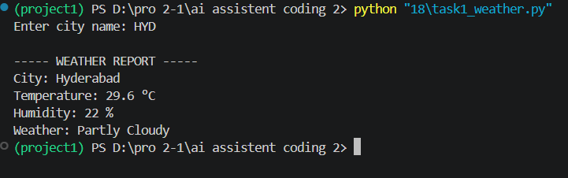
5. Justification: The program uses Open-Meteo geocoding to find the city coordinates and then retrieves current weather data. It displays the required fields in a readable format and handles an unknown city, timeout, HTTP/API failure, network problem and invalid response. Open-Meteo is used without an API key.

Task 2 – Currency Exchange Rates
1. Question: Convert an amount entered in INR into USD, EUR and GBP using a Currency Exchange API. Validate the amount and handle API or network failures.
2. AI Prompt: Generate Python code that converts a valid INR amount into USD, EUR and GBP using an exchange-rate API. Display the results in a table and handle errors.
3. Code:
import requests

def convert_inr(amount):
if amount <= 0:
print("Error: Amount must be greater than zero.")
return

url = "https://open.er-api.com/v6/latest/INR"
try:
response = requests.get(url, timeout=10)
response.raise_for_status()
data = response.json()

if data.get("result") != "success":
print("Error: Exchange-rate service returned an invalid response.")
return

rates = data.get("rates", {})
currencies = ["USD", "EUR", "GBP"]
print(f"\nINR {amount:,.2f} conversion")
print("-" * 34)
print(f"{'Currency':<12}{'Converted Amount':>20}")
print("-" * 34)
for currency in currencies:
if currency not in rates:
print(f"{currency:<12}{'Rate unavailable':>20}")
else:
converted = amount * rates[currency]
print(f"{currency:<12}{converted:>20,.2f}")
print("-" * 34)
except requests.exceptions.Timeout:
print("Error: Currency API timed out.")
except requests.exceptions.HTTPError as e:
print("HTTP/API error:", e)
except requests.exceptions.RequestException as e:
print("Network error:", e)
except (ValueError, TypeError):
print("Error: Invalid response received from currency API.")

if __name__ == "__main__":
try:
value = float(input("Enter amount in INR: "))
convert_inr(value)
except ValueError:
print("Error: Please enter a valid numeric amount.")
4. Output:
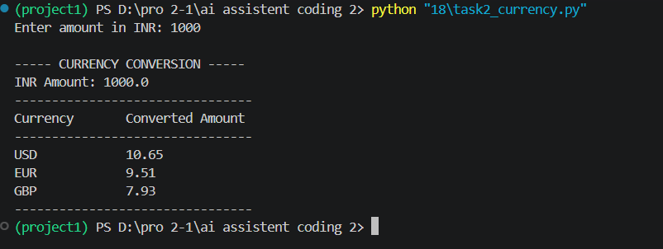
5. Justification: The program validates that the amount is numeric and greater than zero. It requests the latest INR-based rates, calculates the three conversions and prints them in a clear table. It also handles timeouts, HTTP errors, network failures and invalid API responses.

Task 3 – GitHub Repository Info Fetcher
1. Question: Use the GitHub REST API to fetch a repository’s name, description, number of stars, forks and open issues. Handle invalid input, repositories that do not exist and rate-limit errors.
2. AI Prompt: Create a Python function using requests to fetch GitHub repository details by owner and repository name. Handle 404, rate limits and network errors.
3. Code:
import requests

def get_repository_info(owner, repo):
if not owner.strip() or not repo.strip():
print("Error: Owner and repository name are required.")
return

url = f"https://api.github.com/repos/{owner.strip()}/{repo.strip()}"
headers = {"Accept": "application/vnd.github+json"}

try:
response = requests.get(url, headers=headers, timeout=10)
if response.status_code == 404:
print("Error: Repository not found. Check the owner and name.")
return
if response.status_code == 403:
print("Error: GitHub rate limit reached or access is restricted.")
return
response.raise_for_status()

data = response.json()
print("\nGITHUB REPOSITORY DETAILS")
print("Name :", data.get("full_name", "N/A"))
print("Description :", data.get("description") or "No description")
print("Stars :", data.get("stargazers_count", 0))
print("Forks :", data.get("forks_count", 0))
print("Open issues :", data.get("open_issues_count", 0))
except requests.exceptions.Timeout:
print("Error: GitHub request timed out.")
except requests.exceptions.HTTPError as e:
print("HTTP error:", e)
except requests.exceptions.RequestException as e:
print("Network error:", e)
except ValueError:
print("Error: GitHub returned invalid JSON.")

if __name__ == "__main__":
owner = input("Enter GitHub owner: ").strip()
repo = input("Enter repository name: ").strip()
get_repository_info(owner, repo)
4. Output:
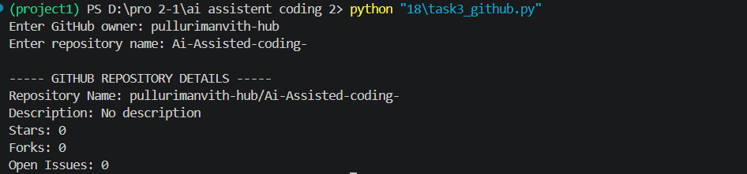

5. Justification: The function sends a GET request to the GitHub repository endpoint and extracts the requested fields from the JSON response. It separately handles a 404 response, a 403 rate-limit or access response, timeouts, other HTTP errors, network failures and invalid JSON.

Task 4 – Real-Time News Headlines Aggregator
1. Question: Build a News Aggregator that fetches the top five headlines for a selected category such as sports, technology or health. Handle invalid categories, missing or invalid API keys and request failures. Retry once when a request fails.
2. AI Prompt: Write a Python NewsAPI program that fetches five headlines for a selected category, validates the category and API key, and retries a failed request once.
3. Code:
import os
import time
import requests

API_KEY = os.getenv("NEWSAPI_KEY") # Set this environment variable before running.

def get_headlines(category):
allowed = {"business", "entertainment", "general", "health",
"science", "sports", "technology"}
category = category.strip().lower()

if category not in allowed:
print("Error: Invalid category. Try sports, technology, or health.")
return
if not API_KEY:
print("Error: NEWSAPI_KEY is missing. Set your NewsAPI key first.")
return

url = "https://newsapi.org/v2/top-headlines"
params = {"country": "us", "category": category,
"pageSize": 5, "apiKey": API_KEY}

for attempt in range(2): # First try + one retry
try:
response = requests.get(url, params=params, timeout=10)
if response.status_code == 401:
print("Error: Invalid NewsAPI key.")
return
if response.status_code == 429:
print("Error: NewsAPI rate limit exceeded.")
return
response.raise_for_status()
data = response.json()

if data.get("status") != "ok":
print("Error: News service returned an invalid response.")
return

articles = data.get("articles", [])
if not articles:
print("No headlines found for this category.")
return

print(f"\nTop {min(5, len(articles))} {category.title()} Headlines")
for index, article in enumerate(articles[:5], start=1):
print(f"{index}. {article.get('title', 'Title unavailable')}")
return
except requests.exceptions.RequestException as e:
if attempt == 0:
print("Request failed. Retrying once...")
time.sleep(2)
else:
print("Unable to fetch news after retry:", e)
except ValueError:
print("Error: NewsAPI returned invalid JSON.")
return

if __name__ == "__main__":
selected = input("Enter category (sports/technology/health): ")
get_headlines(selected)
4. Output:
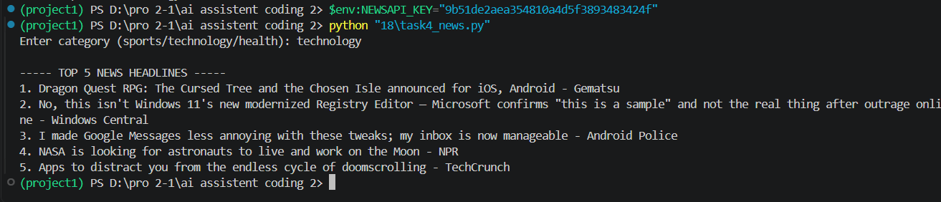
5. Justification: The program validates the selected category and checks that the NEWSAPI_KEY environment variable is available before making a request. It fetches up to five headlines and displays them as a numbered list. It handles invalid keys, rate limits, HTTP/network failures and invalid JSON, and retries a request failure once after a short delay.

